**Nutrition Surveillance Dissemination Platform- Requirements**

1. **Purpose**

The purpose of this document is to describe the requirements that have been defined for the development of an interactive online Nutrition Surveillance Data Dissemination Platform, to guide decision making regarding its development and where it will be housed. This platform will initially be designed for the dissemination of the Compendium of nutrient intake tables from the 2015 Canadian Community Health Survey–Nutrition (CCHS-Nutrition). The long-term goal is to create a central hub for all FD nutrition surveillance data. This document presents (i) background information on CCHS-Nutrition and dissemination methods used for previous nutrition surveillance projects and by other government organizations, (ii) the objectives of the Nutrition Surveillance Dissemination Platform, (iii) requirements and (iv) projected timelines.

1. **Background**

Federal nutrition surveillance data are used by diverse stakeholder groups including but not limited to various federal departments, provinces, health regions, health care professionals, industry, academics, media and the general public. The CCHS-Nutrition, a nationally-representative survey of the nutrition of people in Canada, provides essential data for an evidence-based food and nutrient standard setting and regulatory system and an important line of evidence that supports policies related to dietary guidance. The latest survey was conducted in 2015 and provides a rich source of detailed information on food consumption using a 24-hour (hr) dietary recall for the total sample and a repeat sub-sample, nutrient supplement intake, physical measurements, household food insecurity, and other topics that support the interpretation of the 24-hr recall. It also allows the evaluation of changes that have occurred since this survey was last done in 2004. Development and implementation of the 2015 CCHS-Nutrition has been a joint initiative between Health Canada and Statistics Canada (STC), as also occurred for the 2004 CCHS-Nutrition.

Given the importance of the CCHS-Nutrition data for multiple themes in the HPFB’s Strategic Plan 2016-21 and the broad group of interested stakeholders, dissemination is a key priority. Dissemination of CCHS-Nutrition data is an initiative of Health Canada’s Bureau of Food Surveillance and Science Integration (BFSSI). For 2004 CCHS-Nutrition, nutrient intake data were disseminated in the Compendium of Nutrient Intake Table which consisted of three volumes available on CD and in a limited number of print copies. Food intake data were disseminated through the creation of the Food Consumption Table which has been shared internally at Health Canada and will be posted to the [Open Data Inventory](http://open.canada.ca/en/search/inventory/), the Government of Canada’s portal for accessing their datasets. Health indicators for each province (e.g. fruit and vegetable consumption, household food security, measured body mass index, nutrient intakes from foods, etc.) were disseminated through [Canada’s Nutrition and Health Atlas](https://www.canada.ca/en/health-canada/services/food-nutrition/food-nutrition-surveillance/canada-nutrition-atlas.html) which presented data visually through maps and tables. In addition, dissemination of various analyses occurred through publications in scientific journals and conference presentations.

With 2015 CCHS-Nutrition Compendium of Nutrient Intake Tables soon becoming available, we are seeking an innovative and modern dissemination approach. BFSSI will post the dataset to the Open Data Inventory, thereby fulfilling the commitment to make the 2015 CCHS-Nutrition nutrient intake tables available to the public; however, there is great value in sharing the data in a more interactive, easily digested and user-friendly way. A scan of dissemination and data visualization methods used in the Health Portfolio and other government organizations and discussions regarding relevant tools has provided examples and options to consider. The Public Health Agency of Canada’s (PHAC) [Infobase website](https://infobase.phac-aspc.gc.ca/index-en.html) is a platform through which PHAC helps users to discover and visualize public health data and health indicators. In particular, the [Health Inequalities Data Tool](https://infobase.phac-aspc.gc.ca/health-inequalities/data-tool/) provides an example for which data similar to that collected in CCHS-Nutrition can be visualized in an interactive way. The Infobase is hosted on a PHAC-server which has allowed them to retain administrator rights and the ability to regularly update the site independent of Shared Services. The data tools found on the Infobase have been developed using a number of software programs (e.g. D3, .Net, Powerplay Studio from Cognos). PHAC has expressed willingness to collaborate and to create a Nutrition Surveillance data tool on the Infobase. Other organizations have also developed platforms for disseminating data using interactive means. For example, STC developed a number of data products for the [2016 Census](http://www12.statcan.gc.ca/census-recensement/2016/dp-pd/index-eng.cfm) including the [Focus on Geography Series](http://www12.statcan.gc.ca/census-recensement/2016/as-sa/fogs-spg/Facts-can-eng.cfm?Lang=Eng&GK=CAN&GC=01&TOPIC=10) which provides another example through which CCHS-Nutrition data could be presented. BFSSI has the expertise and capacity to develop the interactive data tools; however, there is a need for a site to house these tools. Based on initial background research and discussions two main options exist: (1) nutrition surveillance data are integrated into the PHAC Infobase; or (2) a new platform to house all nutrition surveillance data is developed and housed on the Health Canada website/cloud environment. The Director General of the Food Directorate has expressed support for integrating nutrition surveillance data into the PHAC Infobase.

The overall goal of the proposed project is to develop an online hub where users can access and visualize nutrition surveillance data. The initial development will focus on the dissemination of the Compendium of nutrient intake tables from 2015 and 2004 CCHS-Nutrition; however, in the longer term it is anticipated that this hub will house additional nutrition surveillance data (e.g. Food consumption tables, Canadian Health Measures Survey, food composition data etc.).

1. **Objectives:**

* Create a hub for the dissemination of nutrition surveillance data
* Provide users with the ability to visualize nutrient intake data generated from CCHS Nutrition (2015 and 2004) in an interactive way

1. **Overview of requirements:**

General requirements for the Nutrition Surveillance Dissemination Platform:

* 1. Creation of an online platform where nutrition surveillance data can be displayed. The core requirement is for a platform for the dissemination of the Compendium of nutrient intake tables;
  2. The ability to display data visualizations (created using platforms such as D3 and .Net)
  3. The ability for BFSSI to regularly update the online platform (either directly or indirectly through a collaborator).
  4. Compliance with accessibility and Treasury Board’s web experience requirements.
  5. The ability to track the use/activity of the site.
  6. The ability for pages on the site to be shared via social media.

Requirements for the dissemination of the Compendium of nutrient intake tables:

1. Data to be drawn from an Excel spreadsheet with data available for intakes of 40 nutrients, 14 age-sex groups, 11 geographic areas (Canada, provinces), 2 time points (2015, 2004). Intake data available as distribution (5th, 10th, 25th, 50th, 75th, 90th, 95th percentiles) and as the percentage of the population above Dietary Reference Intake (DRI) values (estimated average requirement (EAR), adequate intake (AI) and tolerable upper intake level (UL)).
2. Creation of a customizable table to display of the Compendium of Nutrient Intake Tables.
3. Creation of a customizable figure using an appropriate programming platform (e.g. D3, .Net) to illustrate the nutrient intake distributions and relative to Dietary Reference Intakes for priority nutrients of public health concern (e.g. sodium, sugar, saturated fat, potassium, etc.).
4. **Platform Design:**

A potential interface for the 2015 CCHS-Nutrition the Compendium of nutrient intake tables dissemination page based on the PHAC Infobase Health Inequalities Data Tool is displayed below:

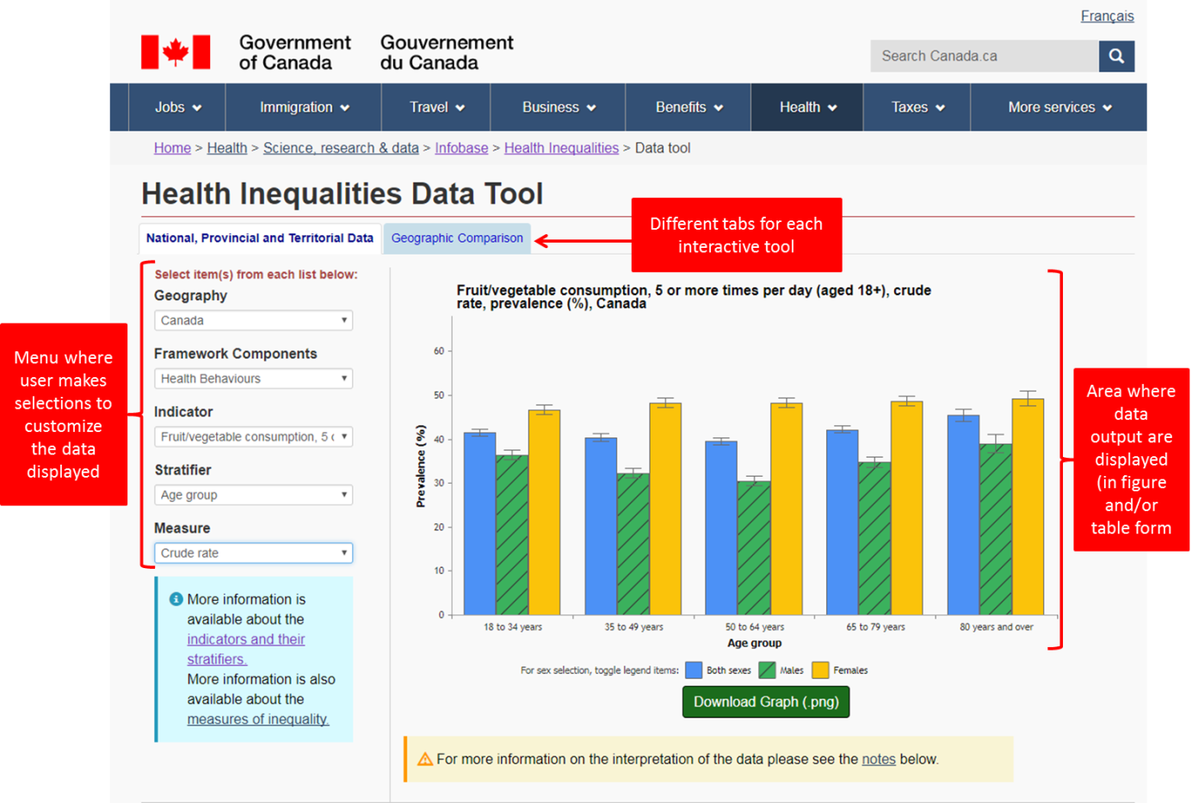

Each figure on the Infobase is followed by a summary data table:

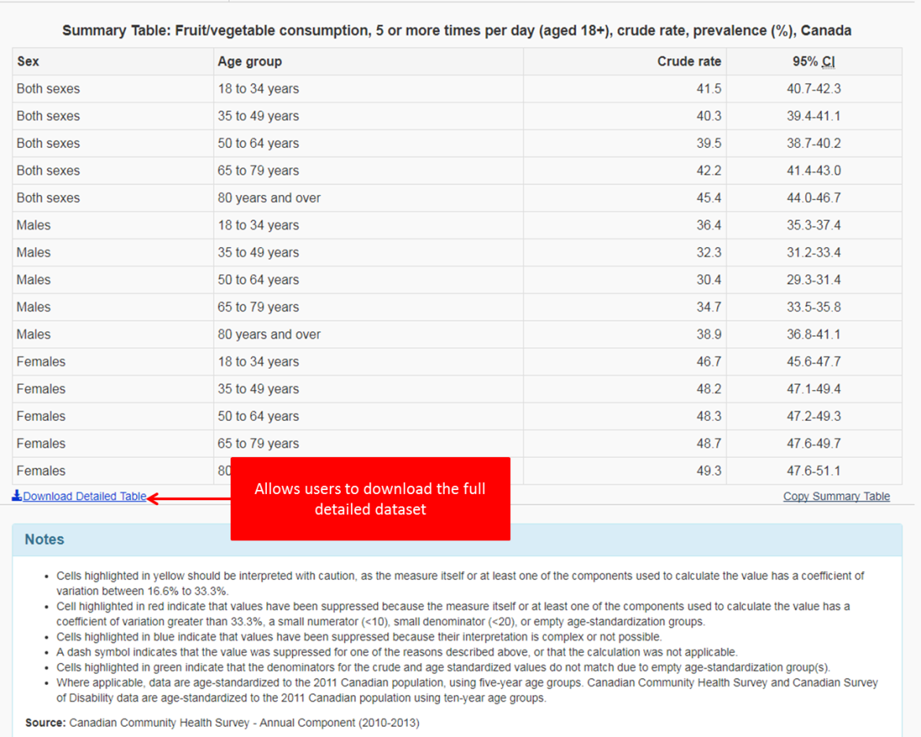

1. **Compendium of Nutrient Intake Tables:**

Changes to the titles, customization steps and placement of the “Download Detailed Table” link are depicted below. A list of the options for each customization step is provided in Appendix 1.

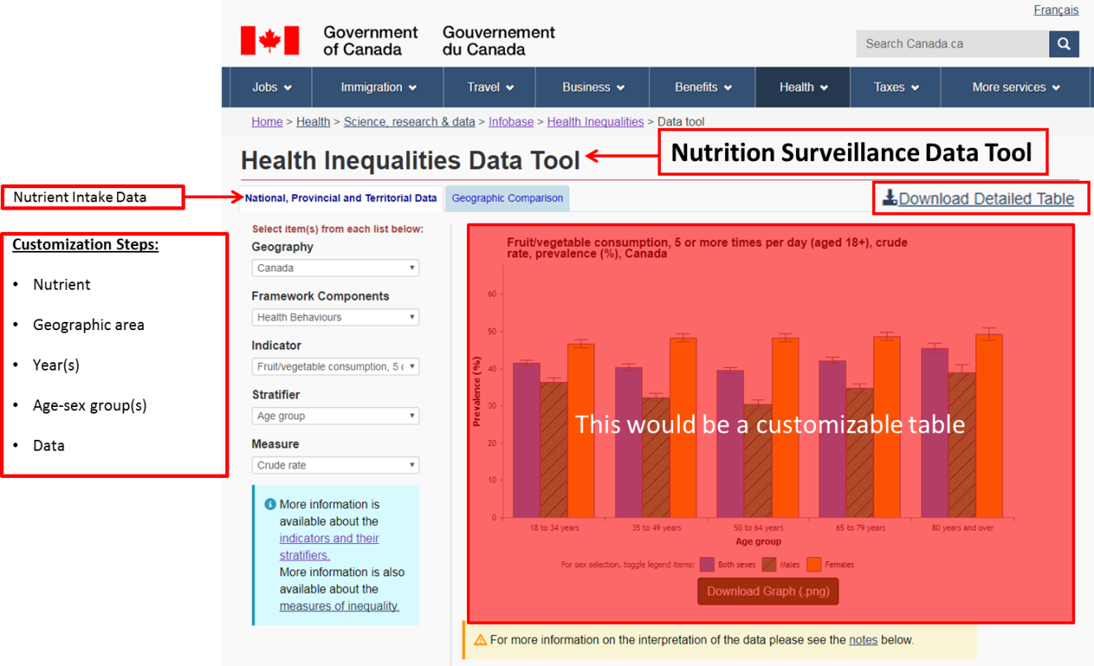

The number of options users will be able to select should differ based on customization step with some requiring the selection of a single response option in a dropdown menu (i.e. nutrient, geographic area) and others allowing the user to select any number of options using check boxes (i.e. year, age-sex group, data). This combination of response options is found on the [Canadian Chronic Disease Surveillance System Data Tool](https://infobase.phac-aspc.gc.ca/ccdss-scsmc/data-tool) on the Infobase as depicted below:

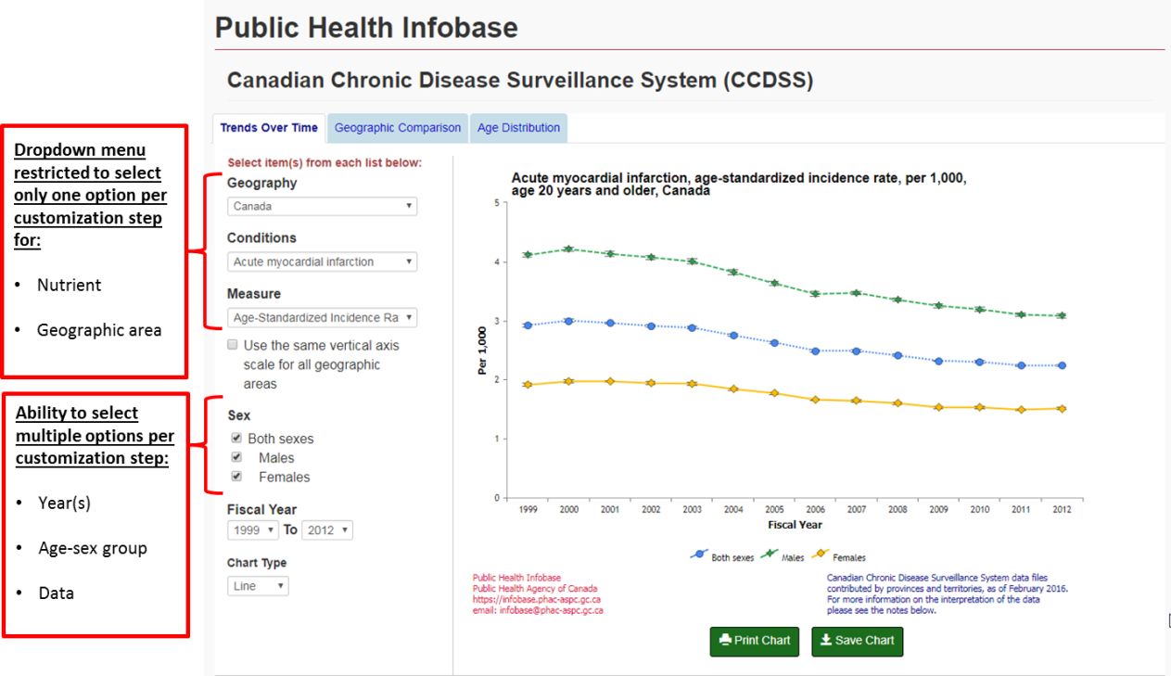

Two versions of the desired final product displaying data based on different customizations are included below:

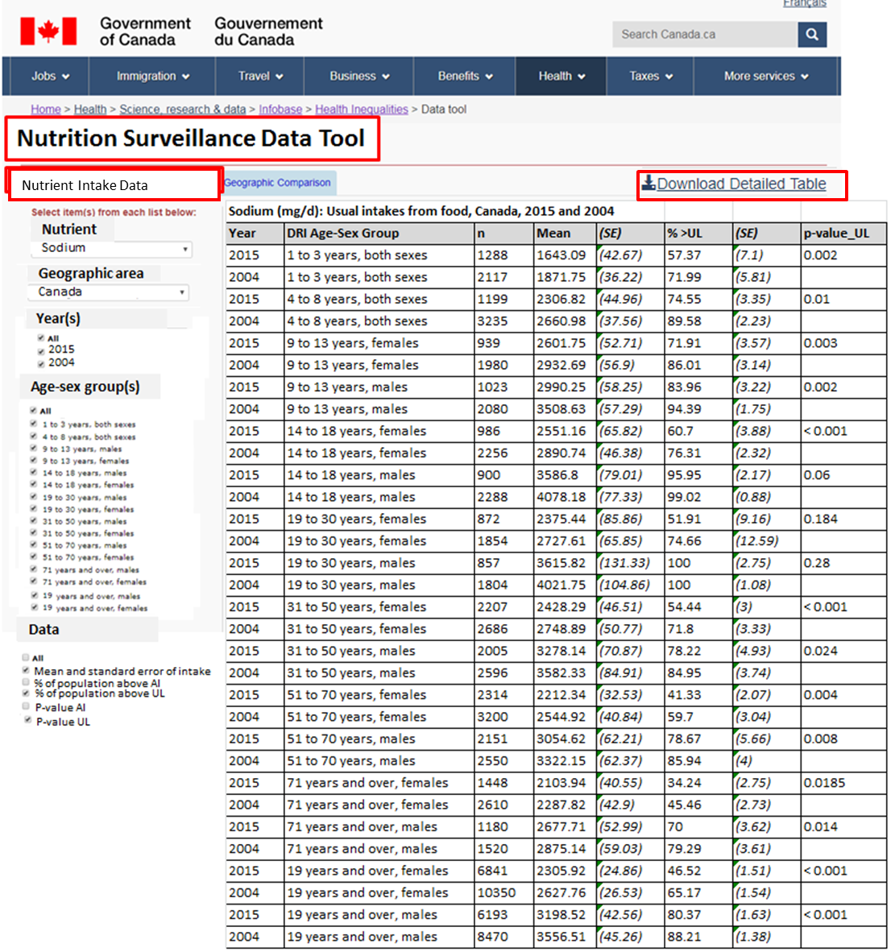

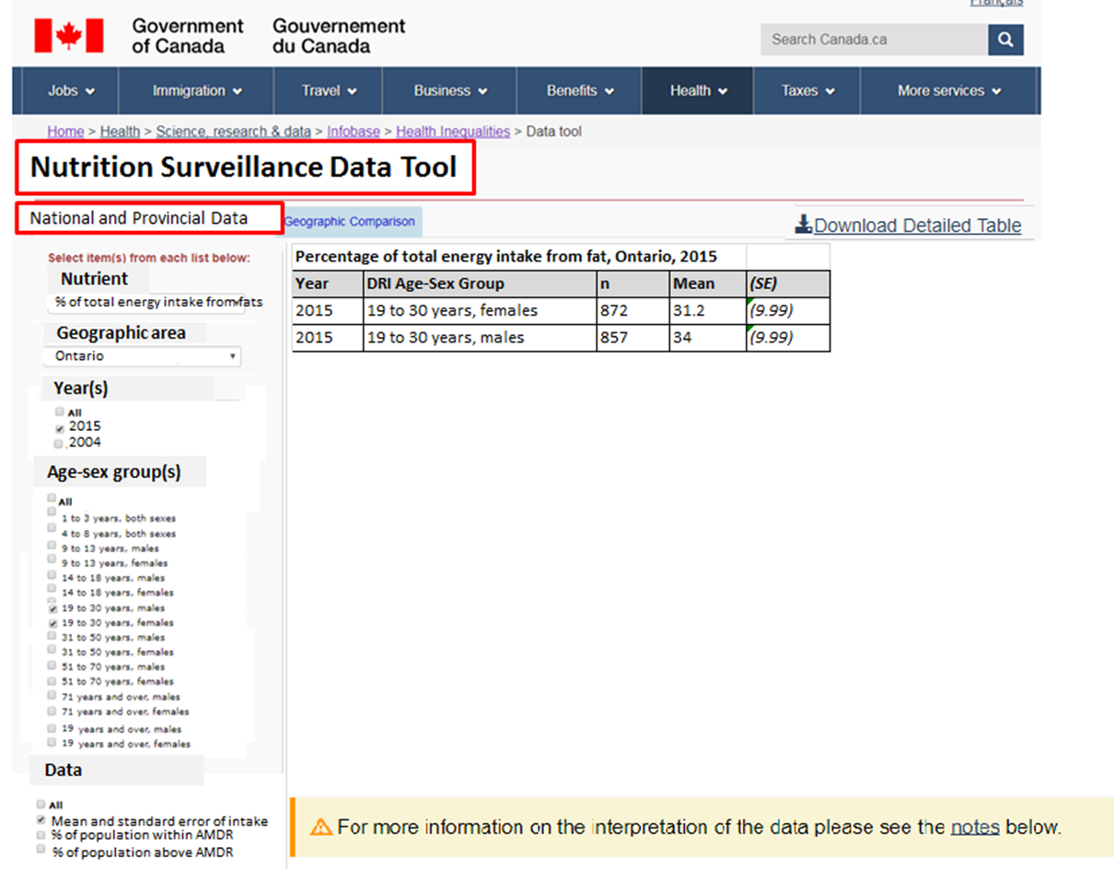

1. The default selections displayed when users first navigate to the page should be: Nutrient: total energy intake
2. Geographic area: Canada excluding the territories
3. Year(s): both
4. Age-sex group(s): all
5. Data: all available options (for energy intake: Mean and standard error of intake, percentage of population within acceptable macronutrient distribution range (AMDR), percentage of population above acceptable macronutrient distribution range (AMDR) )

The detailed table from which the data are drawn is found in the appended excel file (DRAFT_Compendium Table for Dissemination). This file displays the total number of columns in the dataset and the total number of rows for a single nutrient (sodium). In total, data will be available for 40 nutrients.

1. **Intake Distribution Figures:** The second tab of the Nutrition Surveillance Data Tool will include figures displaying the nutrient intake distributions and relevant DRI. Customization steps will be similar to the Nutrient Intake Data Tool with the following modifications.

* Exclude the customization step for Data
* Age-sex should be a single option dropdown menu.

An image of the desired final product is included below:

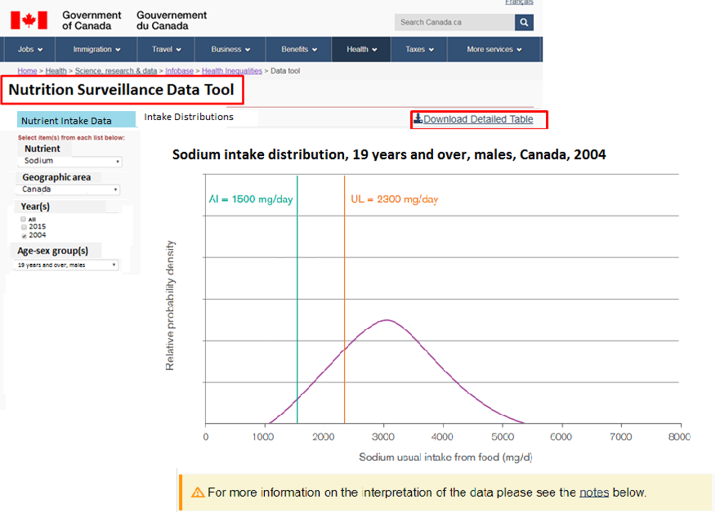

The default selections displayed when users first navigate to the page should be:

1. Nutrient: Sodium
2. Geographic area: Canada excluding the territories
3. Year(s): both
4. Age-sex group(s): 19 years and over, males
5. **Projected Timelines**

Q4 FY 2017-2018: Selection of where the Nutrition Surveillance Dissemination Platform will be housed

Q1 FY 2018-2019: Nutrient intake tables available for all nutrients

Q1, Q2 FY 2018-2019: Programming and creation of customizable table and data visualizations

Q3 FY 2018-2019: Review of accessibility and user experience requirements.

Q3, Q4 FY 2018-2019: Posting and tracking of use/activity of site

1. **Future Directions**

The creation of the Nutrition Surveillance Dissemination Platform presents an opportunity for innovative sharing of nutrition surveillance data beyond the Compendium of Nutrient Intake Tables. CCHS-Nutrition is a rich source of information of interest to diverse stakeholder groups. Some examples of the types of analyses of CCHS-Nutrition data which could be conducted and shared on the platform include:

* Which foods and beverages contribute the most to the intake of nutrients of public health concern in Canada?
* How do food and nutrient intakes differ by various stratifying variables collected in CCHS-Nutrition (e.g. income, race/ethnicity, body weight classification, food security, etc.)
* Are there differences in the types of foods consumed in Canada between 2015 and 2004?
* How does food intake in Canada align with recommendations set out in Canada’s Food Guide?
* How do nutrient intakes differ across the provinces?

Beyond CCHS-Nutrition, the Nutrition Surveillance Dissemination Platform can serve as a hub for nutrition data collected within and outside of Health Canada. Some examples of other data which could be shared on the platform include:

* How has the sodium content of foods in Canada changed over time?
* How has the prevalence of nutrient insufficiency measured through biomarkers in Canada changed over time (e.g. vitamin D, folate)?

**Appendix 1. Response options for customization steps on the Nutrient Intake Data Tool.**

Options for nutrients:

Total energy intake (kcal/d)

Percentage of total energy intake from fats

Percentage of total energy intake from protein

Percentage of total energy intake from carbohydrates

Percentage of total energy intake from saturated fats

Percentage of total energy intake from monounsaturated fats

Percentage of total energy intake from polyunsaturated fats

Total dietary fibre (g/d)

Cholesterol (mg/d)

Total fats (g/d)

Total saturated fats (g/d)

Total sugars (g/d)

Sodium (mg/d)

Vitamin A (RAE/d)

Vitamin C (mg/d)

Folate (DFE/d)

Folacin (mcg/d)

Naturally occurring folate (mcg/d)

Niacin (NE/d)

Riboflavin (mg/d)

Thiamin (mg/d)

Vitamin B6 (mg/d)

Vitamin B12 (mcg/d)

Vitamin C (mg/d)– by smoking status

Vitamin D (mcg/d)

Calcium (mg/d)

Magnesium (mg/d)

Phosphorus (mg/d)

Potassium (mg/d)

Zinc (mg/d)

Moisture (g/d)

Protein (g/d)

Total carbohydrates (g/d)

Linoleic fatty acid (g/d)

Percentage of total energy intake from linoleic fatty acid

Linolenic fatty acid (g/d)

Percentage of total energy intake from linolenic fatty acid

Total monounsaturated fats (g/d)

Total polyunsaturated fats (g/d)

Iron

Options for geographic areas:

Canada excluding territories

Newfoundland and Labrador

Prince Edward Island

Nova Scotia

New Brunswick

Quebec

Ontario

Manitoba

Saskatchewan

Alberta

British Columbia

Prairie Region

Atlantic Region

Options for years:

2015

2004

Both

Options for Age-sex groups:

1 to 3 years, both sexes

4 to 8 years, both sexes

9 to 13 years, males

9 to 13 years, females

14 to 18 years, males

14 to 18 years, females

19 to 30 years, males

19 to 30 years, females

31 to 50 years, males

31 to 50 years, females

51 to 70 years, males

51 to 70 years, females

71 years and over, males

71 years and over, females

19 years and over, males

19 years and over, females

Options for Data:

Mean and standard error of intake

Percentage of population above adequate intake (AI) with standard error estimate*

Percentage of population above estimated average requirement (EAR)*

Percentage of population above tolerable upper intake level (UL) *

Percentage of population within acceptable macronutrient distribution range (AMDR) *

Percentage of population above acceptable macronutrient distribution range (AMDR) *

P-value AI**

P-value EAR**

P-value UL**

*\*options should appear based on which nutrient is selected (e.g. for sodium the AI and UL should appear whereas for percentage of total energy intake from fat only the AMDR options should appear)*

*\*\*only available if user selects both 2004 and 2015 and options should appear based on which nutrient is selected*